**LAB REPORT #9** Name: Owais Rao

**C++ Functions**  Roll No.:22L-7638

Class: BSEE-1A2

**Introduction:-**

A function is a set of statements that take inputs, do some specific computation, and produce output. The idea is to put some commonly or repeatedly done tasks together and make a function so that instead of writing the same code again and again for different inputs, we can call the function. In simple terms, a function is a block of code that only runs when it is called.

**Objective:-**

* To understand how to use pre-defined functions
* To understand how to define your own functions
* To get familiar with value returning functions

**Procedure:-**

With the help of lab manual, I was able to write codes for given exercises. They are as follows with their outputs:-

**Exercise 1:-**

#include <iostream>

#include <cmath>

using namespace std;

double area(double radius)

{

double area, pi = 3.14;

area = 4 * pi * pow(radius, 2);

return area;

}

double volume(double radius)

{

double volume, pi = 3.14;

volume = (4.0/3.0) * pi * pow(radius, 3);

return volume;

}

void main()

{

double radius;

cout << endl << "Enter radius of sphere: ";

cin >> radius;

cout << endl << "Area of Sphere is: " << area(radius) << endl;

cout << endl << "Volume of Sphere is: " << volume(radius) << endl;

} 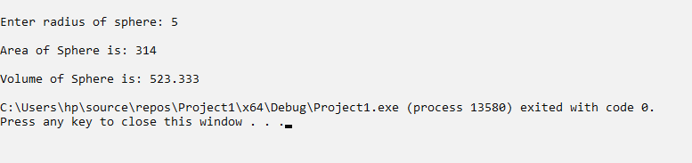

**Exercise 2:-**

#include <iostream>

using namespace std;

double retail(double price, double tax)

{

double retail, t;

t = price * (tax / 100.0);

retail = price + t;

return retail;

}

void main()

{

int price, tax;

cout << endl << "Enter price: Rs.";

cin >> price;

cout << endl << "Enter tax(%): ";

cin >> tax;

cout << endl << "Retail price: Rs." << retail(price, tax) << endl;

}

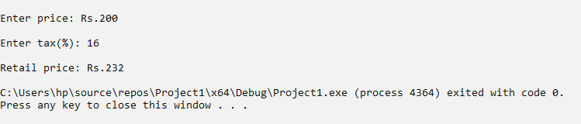

**Exercise 3:-**

#include <iostream>

using namespace std;

char z(char alphabet, int hops)

{

char x;

x = alphabet + hops;

if (x > 90)

{

x = (65 + (x - 91));

}

return x;

}

void main()

{

char alphabet;

int hops;

cout << endl << "Enter character: ";

cin >> alphabet;

cout << endl << "Enter hops: ";

cin >> hops;

cout << endl << "New character: " << z(alphabet, hops) << endl;

}

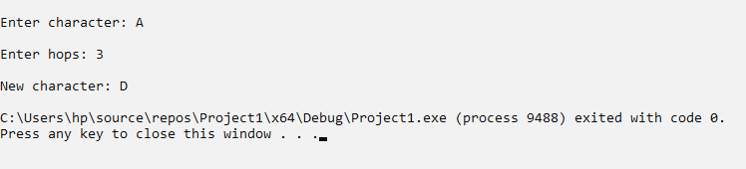 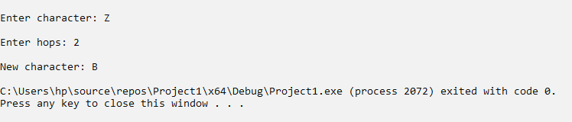

**Issues:-**

No issues were faced.

**Conclusion:-**

* I was able to understand how to use pre-defined functions.
* I was able to understand how to define our own functions.
* I became familiar with value returning functions.

**Applications:-**

* Functions are used to improve the readability and reusability of the code.

**Post Lab (Exercise 4):-**